Homework 4

OCE2901

Braidan Duffy

Explanation

For this assignment, I decided to streamline the process of getting the tidal data by requesting NOAA data through their CO-OPS API using Python. The end goal is to create a series of scripts that scrape data from multiple services such as Surfline, NOAA, Accuweather, etc. to gather wave, tidal, and wind data and weight these values together to create an overall “surfability score”.

For brevity and simplicity, I have just made a test script that scrapes the NOAA API and scores it based on a cosine function. A score of “0” means conditions are not feasible for the class to surf on, tidally speaking; a score of “1” is the opposite. This data was then written onto the calendar and dates with a 90%+ tidal score were highlighted – these are the dates that should be targeted for trials.

There are a few limits as the NOAA API only allows up to 31 days forecast and their forecast model is unknown. The surfability score also does not factor in predicted waves or winds so a “98%” good day could be untenable due to either or both of those variables. The program needs more development, but ultimately, the script should be able to give accurate surfability scores up to 7 days out from its run date and rough estimates out to 31 days.

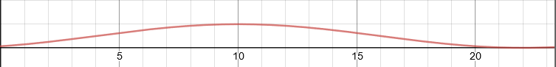

Figure : Plot of the scoring wave used for the tidal algorithm. 10 a.m. was chosen as the ideal time for low-tide to occur (score of 1) and the score approaches 0 as the low tide occurs farther away.